Route an order without a contingency but with price
For example:
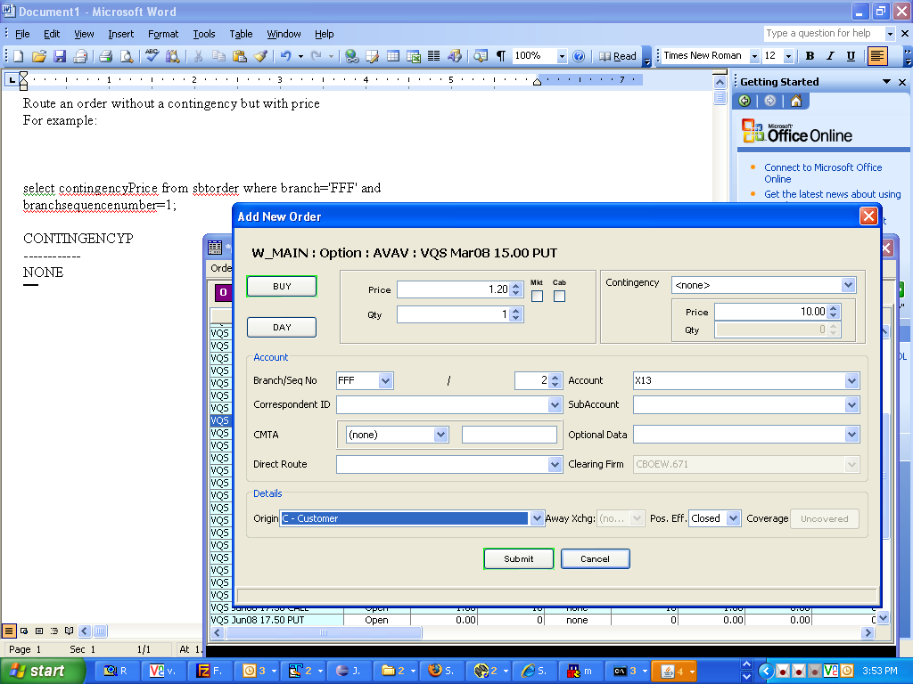

Login to the database:
telnet to the BC you are working on
type: loginDb W_MAIN
at the SQL prompt run the following query.
Replace the branch and branchsequencenumber
select contingencyPrice from sbtorder where branch='FFF' and branchsequencenumber=1;

Enter
The expected result should be:
CONTINGENCYP
------------
NONE

